Video Summarization Using Spatio-Temporal Feature and Clustering Method

A Technical Major Project Report
submitted in partial fulfillment of
the requirement for the B.Tech.
under Biju Patnaik University of Technology, Rourkela.
Submitted By
BARNALI KHATUA |  | Regd : ETC 2101109320
DHIREN KUMAR MAHAL |  | Regd : ETC 2101109326
LIPSA TRIPATHY |  | Regd : ETC 2101109335
MRINMAYEE SAHU |  | Regd : ETC 2101109337
ANISA MAHAPATRA |  | Regd : ETC 2221109025


NOVEMBER - 2024
Under the guidance of
Mrs. T Mita Kumari

Parala Maharaja Engineering College, Sitalapali
Berhampur, Ganjam, Odisha – 761003

ABSTRACT
Video summarization has become an essential task in the age of information overload, where massive amounts of video content are produced daily. With millions of hours of video content produced every day, and with this amount only growing, video summarization is a crucial task in the present age of information overload. This paper introduces a new video summarization method which makes use of deep learning techniques — namely using ResNet-50 and GoogLeNet architectures for feature extraction and temporal modeling respectively. Our model integrates features of state-of-the-art CNNs, which preserves spatial and temporal relations among video sequences for both effective and efficient summarization. We also use k-means clustering to cluster similar frames and find important events to summarize. This approach not only automates the summarization process but also outperforms traditional methods by producing more concise and informative summaries that preserve the essence of the original video. We evaluate the proposed method across a variety of datasets, demonstrating its robustness and generalization capabilities across different video genres. The experimental results show that our deep learning-based approach significantly enhances the efficiency of content consumption by reducing long videos into meaningful, easy-to-digest summaries. This work contributes to the growing field of multimedia analysis and provides valuable insights for real-world applications in video content management and retrieval.

ACKNOWLEDGEMENT
We would like to express my immense sense of gratitude to my guide, Mrs. T Mita Kumari, for her valuable instructions, guidance and support throughout my seminar.

We again owe our special thanks to Mr Raghunandan Swain, Technical Seminar Coordinator, Mr. Nawal Topno, Head of the Department for giving me an opportunity to do this report.

And finally, thanks to Prof. Dr. Chittaranjan Mohanty, Principal, PMEC for his continued efforts for enhancing the quality in everything that happens at PMEC. This report is a dedicated contribution towards that greater goal.

BARNALI KHATUA Regd. #ETC 2101109320
DHIREN KUMAR MAHAL Regd. #ETC 2101109326
LIPSA TRIPATHY Regd. #ETC 2101109335
MRINMAYEE SAHU Regd. #ETC 2101109337
ANISA MAHAPATRA Regd. #ETC 2221109025

TABLE OF CONTENTS
ABSTRACT ii
ACKNOWLEDGEMENT iii
TABLE OF CONTENTS iv
LIST OF FIGURES vi
LIST OF TABLES viii
1. INTRODUCTION 1
1.1 Why Video Summarization 2
1.2 Key Architectures for Video Summarization 2
1.3 Clustering for Video Summarization 4
2.LITERATURE SURVEY 5
3.METHODOLOGY 9
3.1 Data Set 9
3.2 Frame Extraction 11
3.3 Frame Augmentation 11
3.4 Feature Extraction 12
3.5 LSTM 15
3.6 Clustering 17
3.7 Key Frame Extraction 18
3.8 Video Skimming 18
3.9 Accuracy and performance Analysis 18
4.WORKFLOW 21
4.1 Input Dataset 21
4.2 Frame Extraction and Data Augmentation 22
4.3 Feature Extraction 24
4.4 K – Mean Clustering 26
4.5 Key Frame Extraction and Overall F-Score 27
5. APPLICATIONS 29
6.CONCLUSION 30
7.REFERENCES 31

LIST OF FIGURES
Figure 1: Architecture Of ResNet50 Model 14
Figure 2: Architecture of GoogleNet Model 15
Figure 3: Architecture of LSTM Model 16
Figure 4: Workflow Diagram 21
Figure 5: SumMe Dataset 22
Figure 6: Frame Extraction 24
Figure 7: Extracted features using the ResNet-50 Model 24
Figure 8: Extracted features using the GoogleNet Model 25
Figure 9: Concatenated Features 25
Figure 10: LSTM Model 26
Figure 11: Extracted features using the LSTM Model 26
Figure 12: K-mean Clustering 27
Figure 13: Keyframe Index 28

LIST OF TABLES
Table 1:Literature Review 7
Table 2:Data Set 11
Table 3:Confusion Matrix………………………………………………………….……………………………………………..19

1. INTRODUCTION
Video Summarization (VS) aims to extract the necessary video contents in a much shorter form with a similar meaning. Many methods have been contributed for video summarization in which the most import information of a video are selected. Being one of the most resourceful media types, videos are very engaging and can easily grab the attention of users. The development of broadband and cheaper storage quickly made it possible to create huge amounts of video data. YouTube, Netflix, Amazon Prime, Twitter, Facebook, LinkedIn and Wistia are platforms where billions of videos are created; YouTube alone produces more than 10 hours of video every single second.
But videos require considerably more storage and bandwidth to transmit over the Internet than images or text. Truth be told, reviewing large amount of video content manually is both, an expensive as well as a time-consuming task. This creates a increasing demand for the tools and methods which can summarize video data into more compact and consumable formats by summarizing the key insights from large datasets of videos. Video Summarization (VS), a recent activity that focus on analysing videos in such a way to reduce redundant or irrelevant frames and keep only the keyframes which represent the essence of the video content. This allows to speed up the process of scanning through large video libraries, structured access and better organization of video content.
It becomes even more relevant for users who need to skim over video content. It could be used to help. AI technology can automate summarization processes and generate shorter video clips based on long videos into much more content-rich snippets while keeping key contexts intact. VS also can help decreasing the redundancy of frames in a sequence to reduce storage demand and computational load. Summarization techniques seek to give a brief but comprehensive outline of the content of a video by choosing the most important segments. That speeds up processing, storage, management and retrieval of videos to easier interpretation of long videos thus analysing the longer version more conveniently. Video summaries are static if they extract keyframes in multiple places of the video or dynamic if it contains segments of videos that make a strong coherent narrative.

To sum up, video summarization is an important process for allowing large quantities of video content to be managed and used effectively, but also a critical element that enhances user experience and accessibility in so many applications from media streaming platforms to corporate video management systems.

1.1 Why Video Summarization

Video summarization serves several important purposes and brings numerous benefits, making it a valuable tool in various domains. Here are some reasons why video summarization is essential:

Time-Efficiency: Videos often contain a large amount of content that can be time-consuming to watch in its entirety. Summarization provides a condensed version, allowing users to grasp the main points or key events quickly without needing to watch the entire video.

Information Retrieval: Summaries act as a convenient index for videos, enabling users to efficiently search forspecific content or segments within a video library. It makes it easier to locate relevant information without the need for manual scanning or watching lengthy videos.

Resource Optimization: In scenarios where storage, bandwidth, or processing power is limited, video summarization helps in reducing the storage requirements for videos. Smaller-sized summaries can be stored or transmitted more efficiently while still conveying the essential information.

Content Skimming and Browsing: Summaries enable users to preview the video's content and make informed decisions about whether to watch the full video. This is particularly useful in scenarios like online platforms, where users can quickly gauge the video's relevance before committing to watching it entirely.

Visual Analytics and Insights: Video summarization facilitates the extraction of key insights or patterns from a collection of videos, aiding in visual analytics, trend analysis, or understanding recurring themes within video content.
Overall, video summarization plays a pivotal role in managing, analyzing, and utilizing video content effectively across various fields, including education, entertainment, surveillance, healthcare, marketing, and more. Its ability to distill essential information from lengthy videos contributes significantly to enhancing accessibility, efficiency, and comprehension of video content.

1.2 Key Architectures for Video Summarization
1. Convolutional neural network: CNNs are widely used in video summarization tasks due to their powerful feature extraction capabilities. Several popular CNN architectures have been adapted for video summarization, including:
- AlexNet: One of the pioneering deep CNN models, AlexNet is known for its successful application in image recognition tasks. Its architecture comprises convolutional layers followed by fully connected layers and has been adapted for video summarization by extracting frame-level features.
- VGG Networks (VGG16, VGG19): VGG architectures, particularly VGG16 and VGG19, are characterized by their deeper architectures with small (3x3) convolutional filters. These networks have been utilized in video summarization tasks due to their strong feature extraction capabilities.
- ResNet (Residual Network): ResNet's innovative use of skip connections addresses the vanishing gradient problem in deep neural networks, allowing it to learn more robust features in very deep models. ResNet’s architecture has been successfully employed for video summarization to capture intricate details in video sequences.
- GoogLeNet (Inception): The Inception architecture utilizes a multi-branch convolutional approach, enabling the network to learn features at different 4 spatial scales. Inception models have been adapted for video summarization due to their ability to capture diverse information from video frames.
- DenseNet: DenseNet connects each layer to every other layer in a feed-forward fashion, promoting feature reuse. This architecture's compactness and strong feature propagation have made it useful in video summarization tasks.
These CNN architectures, either individually or in combination with other models, are pivotal in extracting meaningful features from video frames or sequences, forming the basis for automatic video summarization systems.
2. Recurrent neural network (RNNs) and LSTMs: Even though CNNs are more suited for spatial feature extraction, Recurrent Neural Networks (RNNs) and Long Short-Term Memory (LSTM) networks aim to capture always-timed relationships between features in video data. RNNs, and especially LSTMs, are good at handling data where context matters, such as time series. Thus, they are the natural choice for video summarization as the order of frames is extremely vital to understand a story. LSTMs allow highlights of significant time events, and checkpoints in videos in which case it outputs to stay the storyline intact when summarizing video.
3. Temporal Convolutional Network (TCNs): Temporal Convolutional Networks (TCNs) are a type of network that extends the convolutional architecture to model sequences, providing a powerful tool for learning from temporal data. Monitoring the architectural principles behind networks applied to learning from sequences. The third strategy is to use TCN for video summarization because it captures long-range temporal dependencies, yet efficient in terms of computation. They are especially helpful in extracting high-level temporal features that help generate short video summaries.

1.3 Clustering for Video Summarization :
Clustering, which is a key element in video summarization, groups similar video segments or frames to detect important events or content for the summary. This is often achieved using k-means clustering, wherein the algorithm clusters video frames based on visual features including colour, texture, motion and scene composition. With suitable clustering methods, the system can automatically select the most representative frames or segments of a video to include in the summary as it should reflect its content. Clustering helps promote efficiency during summarization by reducing the number of frames that require consideration from all the identified frames to only those determined as the most essential.

2.LITERATURE SURVEY
In recent years, significant advancements have been made in the field of video summarization, with various techniques proposed to extract and present key moments from videos. One notable contribution came from J. Mohan and M. S. Nair in 2019, who introduced the concept of static video summarization using sparse autoencoders. Their method focused on reducing video content while preserving essential visual information, allowing for more efficient video summarization. This approach is particularly effective for static videos, where the content does not change drastically over time. In a similar vein, A. Tonge and S. D. Thepade (2022) proposed S-VSUM, a CNN-based technique for static video summarization. By using convolutional neural networks (CNNs), their method extracted relevant features from static video content to generate concise summaries that retain the most significant elements [1][2].
In the same year, S. Kashid, L. K. Awasthi, K. Berwal, and P. Saini (2024) introduced STVS, a spatial-temporal feature fusion approach. Unlike purely spatial techniques, this approach integrated both spatial and temporal features, capturing the context of dynamic video sequences. This method improves the quality of video summaries by incorporating both the appearance of frames and the motion information within the video [3]. The combination of these features is particularly beneficial for videos with high temporal variation. Expanding on the use of clustering techniques, J. Mohan and M. S. Nair (2019) also explored domain-independent static video summarization by combining sparse autoencoders with K-means clustering. This combination optimized feature extraction and clustering, leading to more accurate summary generation for a variety of video types, without being limited to a specific domain [4].
Other notable work includes T. M. Kumari, D. Kumar Dash, and A. Sahu's (2023) proposed method that focuses on texture features and spectral clustering. Their technique aimed to enhance the summarization process by leveraging the texture information in video frames, which is especially useful for videos where colour or spatial patterns play a key role. The use of spectral clustering helped further refine the video summary by grouping similar frames into clusters, ensuring that the most relevant content is highlighted [5]. A. Tonge and S. D. Thepade (2022) also experimented with shot segmentation and K-means clustering for summarizing static video content, where they employed shot segmentation to break the video into meaningful segments before applying clustering to summarize those segments [6].
In the realm of key-frame-based video summarization, A. Dhiman and M. Deshmukh (2023) introduced an optimized K-means clustering approach, focusing on improving clustering accuracy to better identify key frames from videos. Their work optimized the traditional K-means method to select the most representative frames for summary generation, ensuring that the video summary was both concise and informative [7].
Additionally, A. Sahu and A. S. Chowdhury (2021) proposed a method for summarizing egocentric videos by combining deep learning techniques for recognizing, localizing, and summarizing actions. Their approach offered more holistic understanding of the video content, identifying important moments by recognizing user actions and context within the egocentric viewpoint [8]. In another paper, A. Sahu and A. S. Chowdhury (2020) explored use of deep features and optimal clustering to improve video summarization in egocentic videos. Their work highlighted the importance of extracting rich features from the video and then applying clustering techniques to group frames, making the summarization process more accurate and efficient for this specific type of video content [9].
Collectively, these works illustrate a diverse range of approaches in the field of video summarization, each addressing different types of video content, from static videos to dynamic, action-based, and egocentric videos. The incorporation of deep learning models, clustering techniques, and feature fusion methods has significantly advanced the ability to generate efficient and informative video summaries, which are useful in various applications, including content retrieval, surveillance, and media management. Each study contributes to the development of more refined, scalable, and context-aware video summarization techniques, pushing the boundaries of automated video content analysis.

Table 1:Literature Review
Sl no. | Dataset | Feature | Clustering | F-score | Demerit
1. | VSUMM, OVP | SAE | K-MEAN | 0.7(VSUMM)  0.73(OVP) | Scalability issue, Inconsistent video summaries
2. | SUMME &  OVP | CONCATENATED CNN  (ALEX NET,GOOGLE NET,VGG-16) | K-MEAN | KEYFRAME EXTRACTION ACCURACY OBTAINED:  0.934 (SUMME)  0.915 ( OVP) | No F Score data is given
3. | OPEN VIDEO  YOUTUBE  TVSUM  SUMME | SPATIAL FEATURE:  MResGoogleNet  (Modified RESNET50+Modified  GoogleNet)  TEMPORAL FEATURE: LSTM | KOHONEN SOM | ACCURACY OBTAINED:  0.85(OPENVIDEO)  0.864(YOUTUBE)  0.619(TVSUM)  0.536(SUMME) | No F Score data is given
4. | VSUMM OVP | HOG SAE | K-MEAN | 0.72(VSUMM)  0.75(OVP) | High Dimensionality ,Computational Complexity
5. | SUMME | LOOP FEATURE | SPECTRAL CLUSTERING | 0.258 | Prone to false positives or negatives, affecting accuracy
6. | OVP | SHOT SEGMENTATION | K-MEAN | 0.73(OVP) | Computational Complexity , suboptimal  cluster quality leading to less meaningful groupings.
7. | VSUMM | RESNET151V2 | K-MEAN | 0.70 | K-mean clustering, due to its assumption of spherical clusters and sensitivity to the initial selection of centroids.
8. | ADL | SLIC  PHOG  CNN  (GOOGLENET) | OPTIMAL  CLUSTERING  (CSMIK K-MEANS) | 0.870 | This could limit the method's applicability in real-time or resource-constrained environments
9. | SUMME TVSUM50 | CNN  (GOOGLENET) | OPTIMAL  CLUSTERING  (CSMIK K-MEANS) | 0.452(SUMME)  0.629(TVSUM50) | Generalization to Non-Egocentric Videos.

3.METHODOLOGY

3.1 Data Set:
The Open Video Summarization (Open Video SumMe) dataset is designed to facilitate the development and evaluation of open-domain video summarization techniques. This dataset consists of 40 diverse videos spanning various genres such as educational content, entertainment,
1. Open Video Summarization (Open Video SumMe) Dataset:
Open Video (Open Video Summarization) dataset provides a concrete basis for the development and evaluation of open-domain video summarization methods. The dataset comprises 40 different videos from multiple genres (educational, entertainment, vlogs, etc.). The dataset consists of 40 videos, with each video having 10 annotative summaries there by leading to a total of 400 descriptions. This dataset allows for evaluation at the shot level as well as over time, and it can serve as a full-fledged framework to evaluate any form of summarization algorithms. Moreover, the annotations are base on crowdsourced work, allowing a large space of variation in summarization style. It includes video clips, groundtruth summaries and evaluation code to support integration of other summaries.
2. OVPM (Open Video Paragraph Mining) Dataset:
The OVPM dataset is for evaluating paragraph-based video summarization. Dataset: The dataset consisting of 60 videos collected from platforms like YouTube, Vimeo and other public video sites. From tutorials and news broadcasts to travel vlogs and product reviews, these videos cover a wide variety of content. The dataset consists of both video content along with textual summaries that describe what each part of the video is about for each video. The OVPM dataset is one with human-generated paragraph summaries annotated, yielding 15 annotations for each video. The objective is to create algorithms that produce paragraph-level consistent video summaries in terms of natural language and temporal coherence.
3. YouTube Dataset (Large):
500 YouTube videos for a diverse range of genres including music videos, educational tutorials, tech reviews, and lifestyle content. We construct this dataset for large-scale video summarization tasks. In total, 5,000 annotations score each shot in the video [0,1] on how important they are from a group of crowd workers per video. Besides videos and summaries, the dataset also contains user comments and tags that serve as optional metadata to enhance the understanding of context for video summarization models which seek to include this type of information in their summaries. The dataset contains videos from a variety of contents, making it very suitable for training and evaluating models in the difficult arena of open-domain video summarization.
4. TVSum (Title-based Video Summarization) Dataset:
TVSum dataset has been a standard benchmark for title-based video summarization tasks. It is made up of 50 videos covering genres such as news reports, educational tracks, travel documentaries, and others. A total of 1,000 annotations consists of 20 human-annotated shot importance scores for each video. Shot-level annotations are acquired through crowdsourcing and utilized as ground truth to measure the quality of video summaries produced by automatic algorithms. The TVSum dataset provides a common framework to assess the relevance of a summary and test a diverse video summarization method without expensive user studies for each new algorithm.
5. SumMe Dataset (Summarization in Media):
The SumMe dataset is specifically curated for video summarization research. It consists of 25 diverse videos spanning genres such as lifestyle, education, sports, and more. Each video is annotated with a minimum of 15 human-generated summaries, totalling 390 unique annotations across the entire dataset.
The dataset is particularly valuable for studying the variation in human-generated summaries and how algorithms can account for these subjective differences. It provides a robust framework for evaluating video summarization systems, grounded in psychologically-driven principles to reflect how humans perceive video importance. This allows researchers to assess how well automatic systems align with human summarization preferences.
In addition to the videos and annotations, the SumMe dataset includes evaluation code, which simplifies the process of implementing and automating summary evaluations, making it a practical resource for developing and benchmarking video summarization algorithms.

Table 2:Data Set

Data set | videos | annotations | categories
Open video | 50 | 5 | Educational, lecture
YouTube | 50 | 5 | Cartoons, home, news
TVSum | 50 | 20 | Documentary and user generated content
SumMe | 25 | 15-18 | Events, Holidays
OVP | 50 | 5 | Documentary, education

3.2 Frame extraction
The first step in video summarization is converting the input video into individual frames. For the SumMe dataset, this process can be performed using programming libraries like Python. The frames from each video in the SumMe dataset can be extracted using the Python library, which provides efficient functions to read and save frames from video files.
The frames are stored in file directories using Python's os library, making it easy to organize and access the frames for further processing, such as feature extraction.[10] Depending on the video’s frame rate and duration, the number of frames extracted from a single video range from 500 to 4,000 frames.
In this initial frame extraction step, all frames are obtained from the video, regardless of whether they are similar to each other or whether they correspond to key moments in the video. This is because all frames are necessary for training a model that can learn to identify important features and patterns for the summarization task. Once the frames are extracted, the next step is to move on to key frame extraction, where we focus on identifying the most representative frames for summarization.

3.3 Frame Augmentation:
Frame Augmentation for Video Summarization refers to the process of enhancing the quality and diversity of video frames through various transformation techniques to improve the performance of video summarization algorithms. In video summarization, the goal is to condense the video content while retaining the most informative and representative frames. Frame augmentation helps in this process by artificially increasing the variety of available frames, enabling the model to generalize better and capture diverse features. Common frame augmentation techniques include rotation, flipping, cropping, color adjustments, and applying noise, which can simulate different viewing angles, lighting conditions, or distortions that might occur in real-world scenarios. This technique is particularly beneficial in training deep learning models, as it can help them become more robust to variations in the video, such as changes in background, object motion, and scene transitions. By augmenting the frames, video summarization systems can be trained to identify key moments more accurately, even when faced with videos that have complex or non-standard content, ultimately leading to more effective and diverse video summaries.

3.4 Feature Extraction:
The feature extraction in a video summarization method can be define as identifying important visuals in the frame and extract frames to help summarize top few moments of importance from a video. It plays an important role in the extraction of raw video data to summarization algorithm consumable data. Feature extraction uses diverse techniques to extract low-level features (like colors, textures and edges) as well as high-level features (like objects, faces and actions) representing the video content. For this purpose, deep learning models i.e., Convolutional Neural Networks (CNNs) are involved in classifying videos into the required classes based on various feature extortion representation using their respective architectures like ResNet50, GoogLeNetThese models automatically learn features by passing each frame through a number of convolutional layers and pooling layers to compress the dimensions keeping only the most significant information. It gives us a set of feature vectors that summarize each frame's visual contents. These vectors are then used to identify the most representative key frames or segments that represent core content from a video, and select them into the final summary. Feature extraction is important for quality because through feature extraction the algorithm will know redundancy and avoid it thereby delivering only the most precious parts of a video without losing any content.
Feature Extraction Using ResNet-50 for Video Summarization:
The video summarization applications that we have seen so far extract features from the frames, and therefore this step is critical for extracting objects or common patterns in real visual vectors of images to generate a powerful summary. For example, a ResNet50-based approach uses convolutional neural networks (CNNs), which automatically learn relevant visual representations from video data for the purpose of creating features. In this context, ResNet50, a deep convolutional neural networks architecture with a residual learning framework to ease the training of networks that are substantially deeper than those used previously, is particularly successful exploiting it (vanishing gradients).
The architecture of ResNet50 consists of 50 layers of convolutional blocks and is characterized by residual connections (skip connections). Such blocks allow the model to learn deeper features while not being plagued by degradation, a problem that occurs in very deep networks. The residual block has a shortcut path which skips one or more layers to allow the network to learn the residual (difference) between inputs and outputs of each block, enabling effective training. This feature enables ResNet50 to extract high-level and abstract descriptive features that include textures, shape, object from video frames despite the duration of the video being lengthy or the scene being complex for video summarization.
In the process of feature extraction, ResNet50 looks for each frame in the whole video and outputs a features vector highlighting all the importance visuals of this specific frame. These characteristics are often in high-dimensions, and represent rich information about serial visual content such as appearance of objects, motion and environmental distribution from the video. We extract such features by forwarding each video frame across multiple layers of convolutional layer of ResNet50, and then pooling out the irrelevant data to keep only important information. The output consists of dense feature vectors representing the visual information per frame that can be utilized for downstream tasks like video summarization.
These features are determined to be important during video summarization since they provide clue which part of the video contains significant information that needs to be added in summary. Utilizing ResNet50 here means it is a great feature extractor, and this ability combines well with the video content, as there are many complex spatial hierarchies in the frames. These features can be further processed by summarization algorithms to find the keyframes or segments that capture the most informative moments of interest in the video. Such as prioritizing frames with objects, faces or actions (like someone speaking or a car moving) in the summary. Hence, the deeper features learnt by ResNet50 helps the video summarization model to separate content that is important from content that is redundant, which in turn also leads to better results during video summarization.

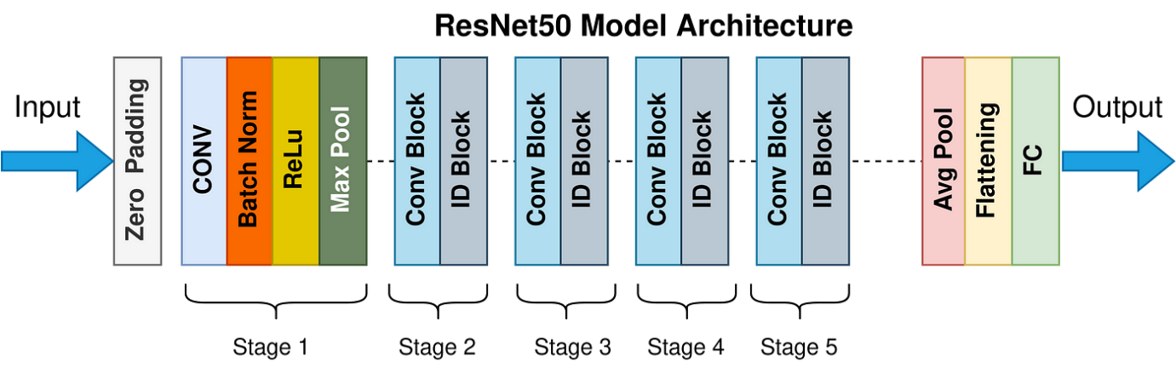
Figure 1: Architecture Of ResNet50 Model

Feature Extraction Using GoogLeNet for Video Summarization:
GoogLeNet is another convolutional neural network architecture that has shown good performance for video summarizing tasks. Built upon the Inception module, GoogLeNet employs maximum performance with a minimal computational budget per layer by adopting parallel convolutions with multiple kernel sizes Running time comparison of different implementations of GoogLeNet. Finally, only the lightest implementation is really any good at training very deep networks typically used in practice. This enables the model to learn various forms of information, from lower-level things such as edges and textures to higher-order patterns like shapes and movements for tasks such as video summarization. GoogLeNet uses the Inception module, which carries out multiple convolutions with different filter sizes (1x1, 3x3 and 5 × 5 kernels) in parallel, while traditional CNN architectures consist of a series of convolutional layers stacked one after each other. This approach is designed to get fine-grained and larger scale visual features simultaneously by allowing the model to extract features of varying scales together. Moreover, the model is built with 1x1 convolutions which work as a kind of dimensionality reduction and reduce computational burden. The unique architecture of GoogLeNet allows it to obtain impressive accuracy using less parameters than compared to traditional deep networks.
The GoogLeNet is ideal for video summarization because it is highly effective at identifying key visual attributes from video frames. As with other CNNs, it runs video frames through the network where each layer of convolutions and pooling are capturing more abstract features. Debugging models can be simple low-level features like edges, corners and textures or high-level features — objects, faces, or a complex activity. The network generates a list of feature vectors each describing what visual features were present in the respective frame. These vectors are all visual information, and therefore make it possible to use these as input into a summarisation model which can aid in the selection of video shots or frame pieces for an eventual summary.
For video summarization the GoogLeNet model effectively records both spatial and temporal information from video data. So, for example, because it learns features of many scales it is able to tell the difference between static content (it detects objects) and dynamic content (it also detects moving objects or actions in one frame). This is very handy for action-packed videos or where the background gets complicated soon. One could further use these feature vectors as an input by applying various temporal analysis strategies like clustering or sequence modelling to fetch those clips which are best representing the whole video & then summarise it. To sum up, GoogLeNet efficient feature extractor can be a good candidate to summarize long and complex video.
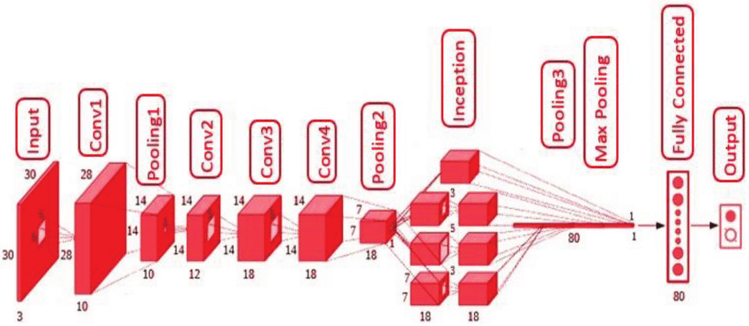
Figure 2:Architecture of GoogleNet Model

3.5 LSTM:
LSTMs or Long Short-Term Memory networks are a special case of RNN with the intended solution to learn long term dependencies from sequential data. The vanishing gradient problem washes out gradients used in training on the earlier timesteps, making them incapable of learning long-range dependencies (one of the key RNN features). To defeat this drawback, you might be able to use a different structure that helps them retain information for longer sequences, especially great for sequential or time-series data-related tasks, like speech recognition, machine translation and video summarization.
LSTM networks have a core innovation that enables them to retain or forget information at different timesteps. A series of gates controlling the information flowing in the network make this possible, providing LSTMs with long term memory when needed, but also forcing them to forget anything not crucial or outdated. An LSTM cell basically has the following key components:
- Forget Gate: This gate determines what part of the previous cell state (memory) will be forgotten or discarded. This gives us a number from 0 to 1, where 0 corresponds to "forget entirely" and 1 corresponds to "pass on state entirely", using the previous hidden state and current input.
- Input Gate: Input gate helps us determine how much new information needs to be stored in the cell state. This part is responsible for deciding which values of the current input should get added to memory (the vector in green), and based on both the current input and the previous hidden state determines this update.
- Cell State: The LSTM unit has a memory that carries information from timestep to timestep which is called cell state. Input and forget gates, which control how much new memory we will write and how much old memory to erase, update it. This allows the LSTM to "remember" important information by sidestepping the vanishing gradient problem.
- Output Gate The output gate specifies what part of the cell state should be output as a hidden state at the current timestep. The hidden state is the output for the next LSTM cell, and can also be used for making predictions or pass through subsequent layers of the neural network.
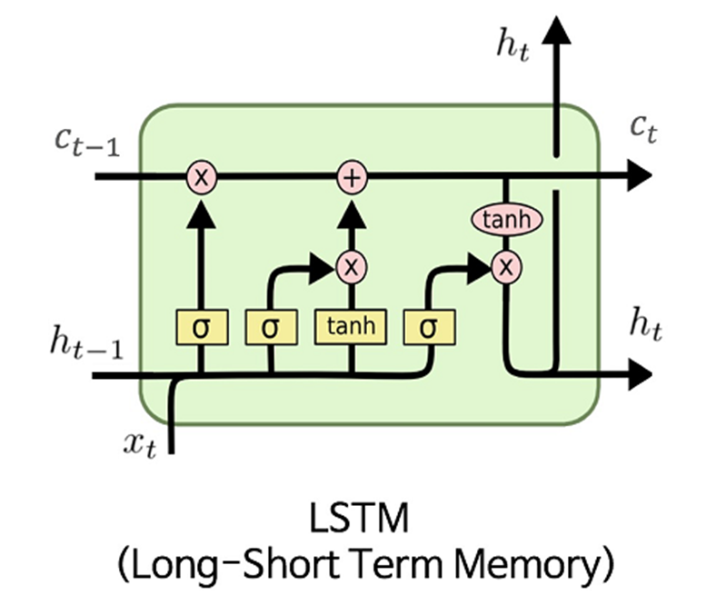
Figure 3: Architecture of LSTM Model

LSTM networks have been proven to progress the SOTA for many relevant sequential applications. In the task of video summarization, for instance, using LSTMs can help pinpoint temporal cuts between shots or key events in a way that automatic summaries contain as much information as possible without losing temporal integrity. This versatility makes LSTMs well-suited for modeling sequential dependencies, which is crucial for applications including but not limited to speech recognition, text generation and even composing music.

3.6 Clustering:
Clustering is machine learning technique which groups a set of objects(also known as points for data point or video frames etc) in to a same category based on their similarity. Clustering aims to make sure that objects in the same cluster are more similar than those from other clusters. A distance metric, often Euclidean distance, is commonly used to quantify the similarity of frames based on features such as color, texture or temporal characteristics. Clustering is a technique of unsupervised learning, it does not demand labeled data and is one of the prominent methods in practice used for data mining, image processing, video summarization to find patterns within high dimensional data and redundancy reduction as well as information extraction.
K-means Clustering: After the clustering process is completed, we choose representative frames from the clusters to build up the video summary. K-means is very effective on the static or repeated content of videos, which can efficiently remove redundant frames, then selects a short clip containing a small number of the final representative set of shapes that represent the overall visual content. But the main limitation of K-means is that it will struggle on dynamic videos, with fast scene changes or complicated temporal relations in which critical moments are unlikely to occur after each other visually. Thus, it minimizes the utility of K-means to summarize videos for higher variation in content or structure, and so more advanced clustering methods will have to be adopted.
Spectral Clustering: Spectral Clustering is a variant of the clustering algorithm that uses the connectivity between the data points to form the clustering. It uses eigenvalues and eigenvectors of the data matrix to forecast the data into lower dimensions space to cluster the data points. It is based on the idea of a graph representation of data where the data point are represented as nodes and the similarity between the data points are represented by an edge. Spectral Clustering is very effective and works well with complex cluster shapes and it doesn’t assume spherical clusters like K-mean. However, the limitations are it can be computationally expensive for large datasets and requires tuning of parameters like similarity function and number of clusters.

Agglomerative Clustering: is a type of hierarchical clustering that builds clusters bottom-up, starting with each data point as its own cluster and merging the closest pairs step-by-step until all points are grouped into one cluster (or a desired number). The key idea is to begin with each data point as its own separate cluster and then progressively merge or split them based on their similarity. It is very effective for specifying the number of clusters in advance (dendrogram helps choose) and works well for nested or non-spherical clusters. However, the limitations are Computationally expensive (especially for large datasets) and sensitive to noise and outliers.

3.7 Key Frame Extraction:
Video summarization is the technique of selecting and extracting key contents from a video while filtering unnecessary frames. This procedure, termed keyframe extraction, targets removing the frames which represent vital visual details such as information about texture, shape or motion. Most of these keyframe extraction methods rely on low-level features which would eventually help to group the frames into the categories of how important it is to keep that frame in the summary and classify them as redundant or irrelevant. Snippet A few common keyframe extraction methods are Uniform Sampling (choosing every kth frame, usually 5–15% of the length of original video for the summary), By comparing the pixel distributions of cumulative frames, Image Histogram comparison detects significant changes in the scene. SIFT (Scale Invariant Feature Transform) which is a local descriptor invariant to transformations. Additionally, methods like VSUMM use clustering techniques such as K-means to group similar frames and select representative ones for summarization.

3.8 Video Skimming:
Video skimming involves clipping the highlights of a video to select relevant parts and form a summary. Our main approach involves segmentation, which divides a video into shorter units, called skim units, according to visual and auditory signals. Segmentation is done through techniques such as color histogram difference, change point detection and motion based segmentation and some of the advanced techniques also harness SVD or graph partitioning to improve shot clustering. After determining the segments, importance is calculated for every skim unit (for each frame or by keyframe) to select which segments should be part of the summary.

While redundancy removal removes similar units to prevent recurrence, the skim unit selection procedure guarantees that the most crucial segments are selected. The importance score, which may be influenced by motion, semantics, or emotional effect, is used to choose the skim units. Preferences for individualized video skimming can be established according on the viewer's interests (action, romance, etc.) or particular material (people, objects, etc.). The objective is to produce an efficient synopsis that focuses on the most important events, making it applicable to sports, surveillance, and movie summarization, among other applications.

3.9 Accuracy and performance Analysis:
The SumMe dataset provides individual scores to each annotated frames. Well, it is a performance measurement for machine learning classification problem where output can be two or more classes. It is a table with 4 different combinations of predicted and actual values.

Table 3: Confusion Matrix
CONFUSION MATRIX |  | Actual
 |  | Positive | Negative
Predicted | Positive | True positive  (TP) | False positive  (FP)
 | Negative | False  Negative  (FN) | True  Negative  (TN)

It is extremely useful for measuring Recall, Precision, Specificity, Accuracy, and most importantly AUC-ROC curves. In machine Learning, classification is the process of categorizing a given set of data into different categories. In Machine Learning, To measure the performance of the classification model we use the confusion matrix. Through this tutorial, understand the significance of the Confusion Matrix[11].
What is Confusion Matrix?
A confusion matrix is a matrix that summarizes the performance of a machine learning model on a set of test data. It is a means of displaying number of accurate and inaccurate instances from the model‟s predictions. It is often usedto measure the performance of classification models, which aim to predict a categorical label for each input instance. The matrix displays, the number of instances produced by the model on the test data.
• True positives (TP): occurs when the model accurately predicts a positive data point.
• True negatives (TN): occurs when the model accurately predicts a negative data point.
• False positives (FP): occurs when the model predicts a positive data point incorrectly.
• False negatives (FN): occurs when the model predicts a negative data point incorrectly.
Why Do We Need a Confusion Matrix?
- Accuracy:
Accuracy is used to measure the performance of the model. It is the ratio of the total number of correct instances to the total number of instances.
$R=\frac{\sum{TP}}{\sum{TP+\sum{FN}}}$ ..……….(3.1)
- Precision:
Precision is a measure of how accurate a model’s positive predictions are. It is defined as the ratio of true positive predictions to the total number of positive predictions made by the model.
$P=\frac{\sum{TP}}{\sum{TP+\sum{FP}}}$

..……… (3.2)
- Recall:
Recall measures the effectiveness of a classification model in identifying all relevant instances from a dataset. It is the ratio of the number of true positive (TP) instances to the sum of true positive (TP) and false negative (FN) instances.
- F-Score:
The F-score is used to evaluate the overall performance of a classification model. It is the harmonic mean of precision and recall, providing a balance between the two metrics.
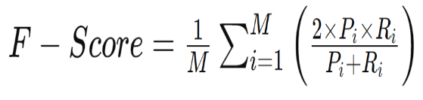 ..……… (3.3)

4.WORKFLOW:
Video input is the first step in the video summarizing process. Frame extraction is then done to extract individual frames from the video. These frames are then enhanced to boost the resilience of the model and diversify the dataset. After that, deep learning models like ResNet50 and GoogLeNet are used to extract features from the frames. The outputs of both models are then blended to take advantage of both networks' advantages. In order to record sequential information and temporal dependencies, the processed features are run through an LSTM network. Similar frames or segments are grouped using K-means clustering, and the most representative frames are chosen from each cluster using key frame extraction. In the end, this process produces a succinct synopsis that preserves the key elements of the original video.

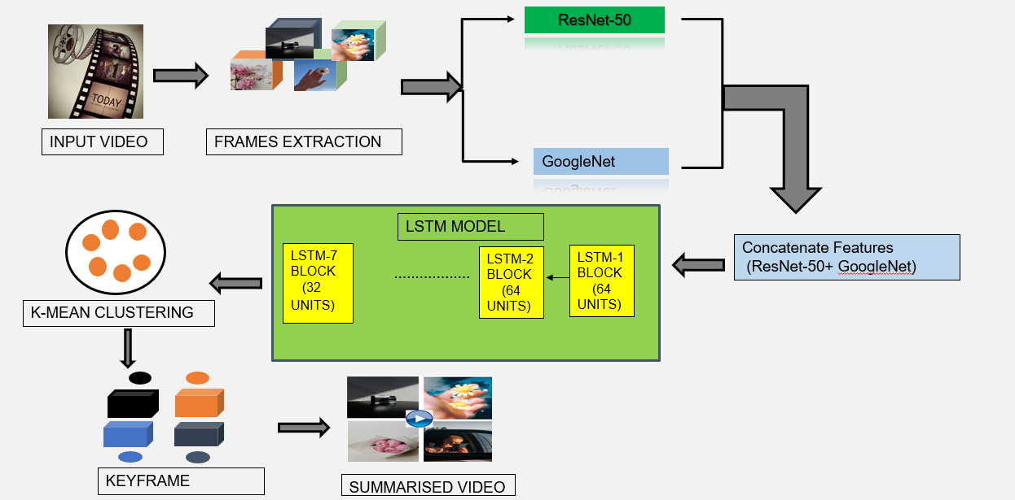
Figure 4:Workflow Diagram

4.1 Input Dataset:

The SumMe dataset has been used as the input dataset. It consists of three main categories of videos: egocentric (4 videos), moving (17 videos), and static (4 videos). These videos are user-generated and cover various events such as holidays, occasions, and sports events. Most of the videos range from 1 to 5 minutes in length. The dataset contains 25 videos, each annotated with at least 15 human-generated summaries (a total of 390 summaries).
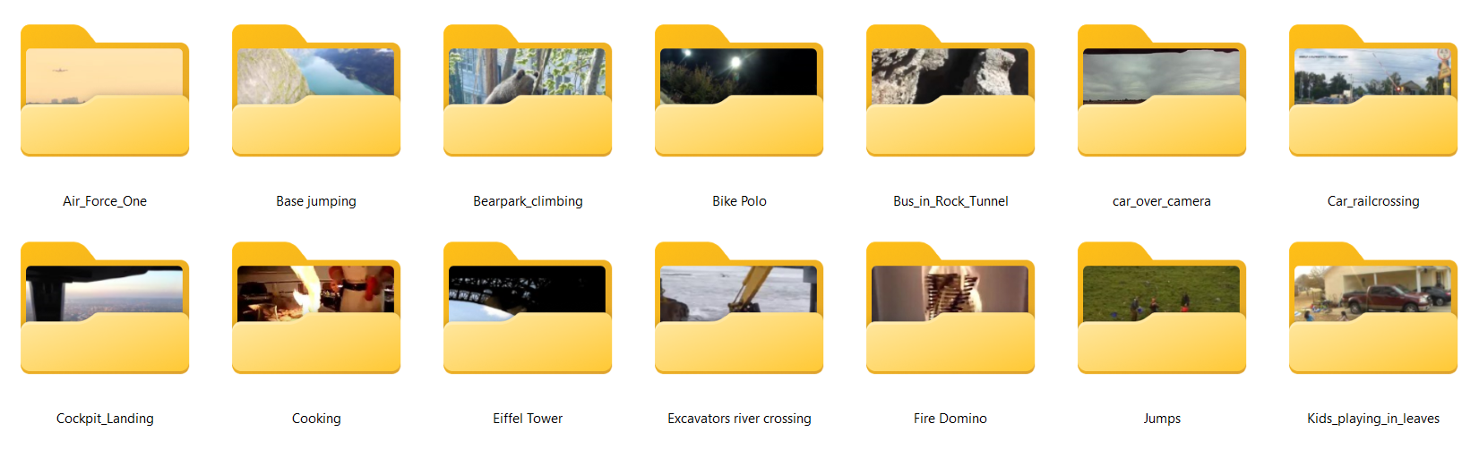
Figure 5:Summe Dataset

4.2 Frame Extraction and Data Augmentation:

In our case, it is applied to the jump’s videos in the SumMe dataset and prepares them for video summarization by extracting the frames and augmenting with several data transformation. The data-preparation part accompanied this process to extract single frames from the video and then augment these images to be more diverse and robust. Here is a complete breakdown of these steps:

Video Loading:

Goal: Download the jumps video file from SumMe dataset for processing.

Steps: Video processing libraries such as OpenCV are directly used for loading a video file since they manage decoding and frame extraction.

Frame Rate Determination:

Nomination: Specify how often frames will be sampled.

Procedure: Find the frame rate in the video metadata which indicates how many frame is shown per second. The helps in identifying how often frames should be pulled out.

Decoding and Reading Frames:

Task: Frame by frame decode Summe video

Taking Procedure: Decode the video, Read frame-wise. Decomposing a video into separate visual items is crucial since this allows us to analyse them separately.

Requirements: Choose the library that supports encoding of the video. Ensure it supports the codec of videos passed in by user.

Frame Storage: Save the extracted frames for future analysis.

Frame Numbering and Timestamps:

Purpose: Maintain the order of frames from f1 to fn.

Procedure These are stored and sequenced by either unique identifiers or timestamps to maintain the order frames are received in. This is relevant for summarization process and further analysis.

Data Augmentation:

Purpose: For frame augmentation to increase the diversity of this dataset so that model can be more robust and Generalized over a range of visual conditions.
- Techniques Applied:
- Geometric Transformations: (e.g., random rotation [−30° to +30°], scaling [zooming in or zooming out], and horizontal or vertical flipping [simulating a different viewing angle or zoom level]).
- Colour Space Augmentation: Change the brightness, contrasts, saturation and hue of the frames to mimic natural changes such as lighting or colour change that may take place in a video.
- Add Gaussian or salt-and-pepper noise to mimic real-world imperfections such as low light situations, or compression artifacts.
- Blurring and Sharpening: Gaussian Blur helps to imitate the motion blur or out-of-focused frames while sharpen helps to increase the sharpness of fine details.

Augmentation Implementation:

Procedure: Data augmentation is usually done on the fly (this refers to whether this process happens and in what condition) using libraries like Tensorflow or PyTorch, which can do this transformation on real time as the training progresses. This is because the augmented frames are created on-the-fly for each training batch so it does not necessitate huge storage volume for augmented data.

Storage and Organization of Augmented Data:

Purpose: This is to make sure that you have stored and arranged your augmented frames for further processing later on.

Procedure: Save augmented frames in the same directory as original frames with an identifier attached (eg, _aug) It organizes a pipeline for your training and evaluation process.
The reasoning for these steps is to get the extracted frames in such a way that it tells us a story in terms of jumps and at the same time also ensuring we have a non-repetitive set of images which will lead to better generalisation for our model. These stages are one of the core modules in the video summarization pipeline to produce stronger and more accurate summaries for dynamic content such as jumps in sports events.

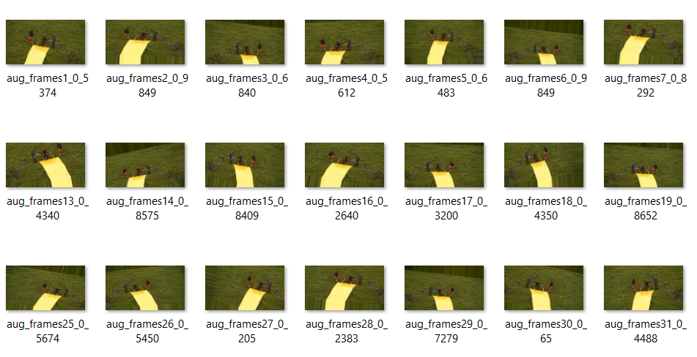
Figure 6:Frame Extraction

4.3 Feature Extraction
- ResNet-50 Feature Extraction:
- Output 950 frames gave 2048-dimensional feature vectors extracted from average pooling layer of ResNet-50 model.
- Feature Shape: The feature matrix is (950,2048)
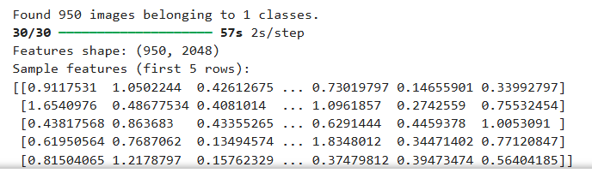
Figure 7:Extracted features using the ResNet-50 Model

- GoogLeNet (InceptionV3) Feature Extraction:
- Output: Analogously to VGGFace([8]), GoogLeNet model was used to extract 2048 dimensional feature vectors for 950 frames.
- Feature Shape: The feature matrix has dimensions (950, 2048).
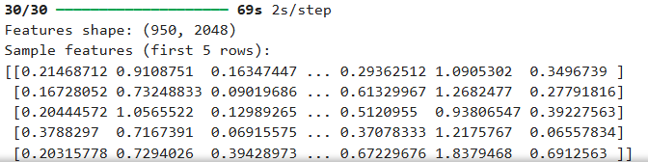
Figure 8:Extracted features using the GoogleNet Model

- Feature Fusion (ResNet-50 + GoogLeNet):
- Output: The feature vectors from ResNet-50 (2048-D) and GoogLeNet (2048-D) were concatenated to form a fused feature vector of size 4096-D.
- Feature Shape: The resulting feature matrix from the fusion has dimensions (950, 4096).
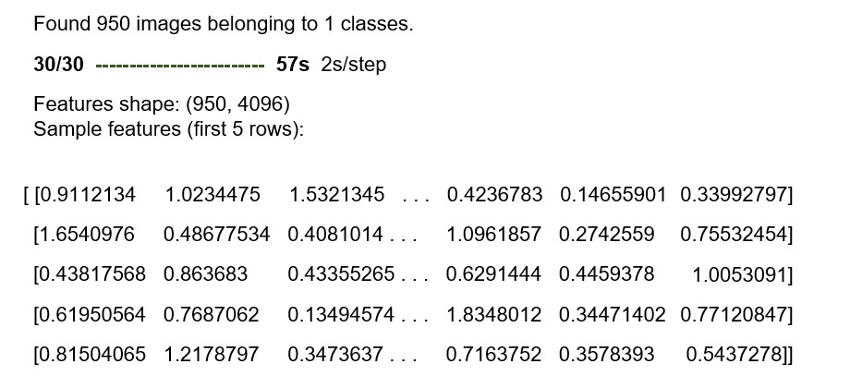
Figure 9:Concatenated Features

- LSTM Temporal Feature Extraction:
- LSTM networks capture the temporal consistencies among video frames to be able to learn something about the sequential characteristics of video data. Sequential features (detected by spatial feature extraction models like ResGoogleNet or M-ResGoogleNet) are fed to an LSTM network, which describes how the frames evolve over time.
- The LSTM architecture includes seven LSTM layers that are responsible for learning the temporal relationships between successive frames in the video. Each LSTM layer has gates that regulate the flow of information and allow the network to learn important temporal patterns.
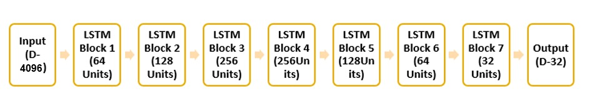
Figure 10:LSTM Model
- The final output from the LSTM model is a 32-dimensional vector for each video frame, which represents the learned temporal features.
- Output: Temporal dependencies were captured using the LSTM network, which produced 32-dimensional feature vectors for every one of the 950 frames.
- Feature Shape from LSTM: The final temporal feature matrix has dimensions (950, 32).
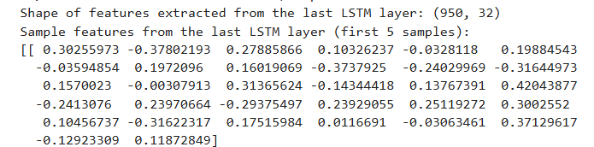
Figure 11:Extracted features using the LSTM Model

4.4 K – Mean Clustering:
In this experiment, we took the deep learning models AlexNet50 and GoogLeNet which we trained previously on a sequence of frames and utilized its features representations. Fusing features of the two models produced a thorough holistic representation of the input. The features were then passed through a Long Short-Term Memory (LSTM) network to preserve temporal dependencies over time series. This provides us the final output of this process with its shape (950,32 So that means we have 950 sequences and each sequence has dimensions 32 It is a critical step when it comes to sequential data, and the model will need to be trained on the timing dynamics relevant for tasks such as video classification or action recognition.
With that being said, we did K-means clustering of all the frames to form clusters of them based on feature similarity to gain insights from the extracted features. K-means,an unsupervised algorithm that classifies data by clustering into K groups where the variance inside each cluster is minimum. For our case, we have 950 frames and so we have 143 clusters (Each cluster is made of Group of 50 frames). We only grouped the frames so that we would know how to visually cluster the frames based on similar set of features or behaviour these clustered frames. K-means clustering does not require any form of labeled information and works quite well for finding structure in data based only on the measurements that we have made, hence has been used to group activities, segment scenes or even detect anomalies and lot more tasks over video datasets.
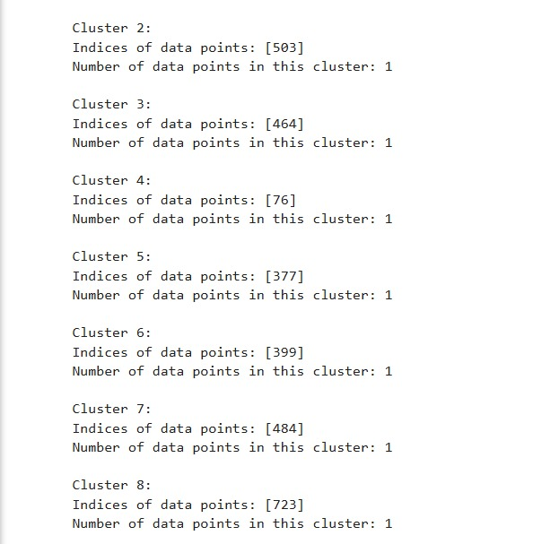
Figure 12:K-mean Clustering

Spectral Clustering:
In this experiment, we took the deep learning models AlexNet50 and GoogLeNet which we trained previously on a sequence of frames and utilized its features representations. Fusing features of the two models produced a thorough holistic representation of the input. The features were then passed through a Long Short-Term Memory (LSTM) network to preserve temporal dependencies over time series. This provides us the final output of this process with its shape (950,32 So that means we have 950 sequences and each sequence has dimensions 32 It is a critical step when it comes to sequential data, and the model will need to be trained on the timing dynamics relevant for tasks such as video classification or action recognition data, and the model will need to be trained on the timing dynamics relevant for tasks such as video classification or action recognition. With that being said, we did Spectral clustering of all the frames to form clusters of them based on feature similarity to gain insights from the extracted features. Spectral Clustering is a variant of the clustering algorithm that uses the connectivity between the data points to form the clustering. It uses eigenvalues and eigenvectors of the data matrix to forecast the data into lower dimensions space to cluster the data points. It is based on the idea of a graph representation of data where the data point are represented as nodes and the similarity between the data points are represented by an edge. The step builds the Similarity Graph in the form of an adjacency matrix which is represented by A. The adjacency matrix can be built in the following manners:
- Epsilon-neighbourhood Graph: A parameter epsilon is fixed beforehand. Then, each point is connected to all the points which lie in its epsilon-radius. If all the distances between any two points are similar in scale then typically the weights of the edges ie the distance between the two points are not stored since they do not provide any additional information. Thus, in this case, the graph built is an undirected and unweighted graph.
- K-Nearest Neighbours A parameter k is fixed beforehand. Then, for two vertices u and v, an edge is directed from u to v only if v is among the k-nearest neighbours of u. Note that this leads to the formation of a weighted and directed graph because it is not always the case that for each u having v as one of the k-nearest neighbours, it will be the same case for v having u among its k-nearest neighbours. To make this graph undirected, one of the following approaches is followed:-
  - Direct an edge from u to v and from v to u if either v is among the k-nearest neighbours of u OR u is among the k-nearest neighbours of v.
  - Direct an edge from u to v and from v to u if v is among the k-nearest neighbours of u AND u is among the k-nearest neighbours of v.
  - Fully-Connected Graph: To build this graph, each point is connected with an undirected edge-weighted by the distance between the two points to every other point. Since this approach is used to model the local neighbourhood relationships thus typically the Gaussian similarity metric is used to calculate the distance.
This step is done to account for the possibility that members of the same cluster may be far away in the given dimensional space. Thus, the dimensional space is reduced so that those points are closer in the reduced dimensional space and thus can be clustered together by a traditional clustering algorithm. It is done by computing the Graph Laplacian Matrix.

4.6 Agglomerative Clustering:
In this experiment, we took the deep learning models AlexNet50 and GoogLeNet which we trained previously on a sequence of frames and utilized its features representations. Fusing features of the two models produced a thorough holistic representation of the input. The features were then passed through a Long Short-Term Memory (LSTM) network to preserve temporal dependencies over time series. This provides us the final output of this process with its shape (950,32) So that means we have 950 sequences and each sequence has dimensions 32 It is a critical step when it comes to sequential data, and the model will need to be trained on the timing dynamics relevant for tasks such as video classification or action recognition data, and the model will need to be trained on the timing dynamics relevant for tasks such as video classification or action recognition. With that being said, we did Agglomerative clustering of all the frames to form clusters of them based on feature similarity to gain insights from the extracted features. Agglomerative clustering is a hierarchical clustering algorithm that starts with each data point as its own cluster and iteratively merges the closest clusters until a stopping criterion is reached. It is a bottom-up approach that produces a dendrogram, which is a tree-like diagram that shows the hierarchical relationship between the clusters. The algorithm can be implemented using the scikit-learn library in Python. The Agglomerative clustering allows easy interpretation of relationships between data points. Unlike k-means clustering, we do not need to specify the number of clusters. It is very efficient and can identify small clusters.

4.7 Key Frame Extraction and Overall F-Score:
We performed K-means clustering on the 950 frames with result of 143 clusters and we selected one key frame from each cluster to represent its group. In our case, the key frame was selected from each cluster as one that could represent or characterize salient features of the frames in that group. As we take only one frame out of these 151, this action could help us reduce the amount of video data while retaining visual and temporal information. The 143 key frames are the highlight of the original video content, represents the deep summary content of overall video. This video summarization approach is useful in applications like video retrieval for efficient browsing or down the line quick analysis of content where a compact representation of the video is enough to capture all the significant events or scenes in it.
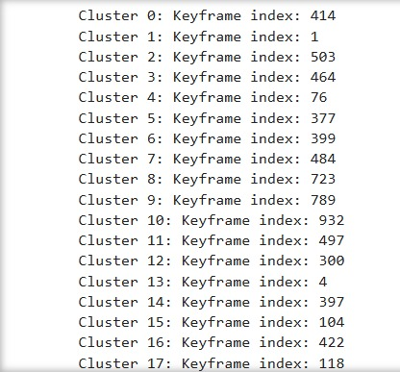
Figure 13:Keyframe Index
Fig. 13: Keyframe index
We applied the summarization method on node pairs of key frames selected from 143 clusters before verifying our performance measures using the JUMPS video from SumMe dataset. We evaluated it by comparing the extracted key frames with ground truth annotations of 15 human annotators. In this method, some evaluation metrics are employed for evaluating the performance of summarization like F-score, accuracy and precision. The F-score which is a trade-off for precision and recall was particularly useful to evaluate the degree of match between extracted key frames and human annotations, whilst balancing key frames relevance (precision) with coverage of the entire video (recall).
JUMPS video F-score average was 0.3423 overall, which determine the moderate performance level for key frame extraction and video summarization [4]. This F-score represents a fair trade-off between recall (picking relevant frames) and precision (not picking irrelevant frames). However, this result is encouraging and indicates that there is certainly room for improvement. Future work could improve the summarization by enhancing the feature extraction, temporal modelling or clustering processes, as well as exploring more sophisticated key frame selection strategies.

5. APPLICATIONS
Video summarization can be beneficial in different real-life applications of several domains by following efficient processing and information extraction from lengthy video sequences. Summarizing a video reduces the amount of footage that needs to be reviewed, and all that time-consuming footage is reduced to only the most relevant clips which fast track decision-making, improving productivity and creating an awesome user experience. Now, here are some of the significant applications of the video summarization:
- Healthcare and Medical Imaging: Extracting useful information from such longer duration videos of’ medical procedure or patient monitoring is too time consuming for the medical professionals and thus not very efficient for accurate diagnosis and treatment decision [2].
- Security and Surveillance: Video summarization can allow us to analyze large amount of surveillance video to get important events highlight without manually reviewing the video.
- Security and Law Enforcement: Video summarization can make the job of security teams simpler by marking the essential incidents in surveillance footage as suspicious activity involved individual behavior or criminal activity so that in case a law enforcement official intervenes, they can focus on critical events.
- Social Media Content: Video summarization can facilitate features in platforms like Instagram and TikTok by allowing important moments from long videos to be identified so that users can quickly access engaging portions of user-generated content.
- Corporate and Event Recording: Video summarization can be applied to corporate meetings or conferences to create summarized, shorter videos of long videos, enabling viewers to quickly find out.
- Autonomous Vehicles: In the context of autonomous vehicles, where footage from over a dozen cameras need to be processed quickly and loads of data captured by such devices leads to analysis bottlenecks, video summarization can provide crucial assistance by surfacing critical events (like accidents or near-misses) for faster decision-making, making the vehicle safer and improving its decision-making systems.

6.CONCLUSION
In this work, we worked with deep learning-based techniques for video summarization using ResNet-50, GoogLeNet and LSTM along with K-means clustering. Feature extraction is a two-step process where in the first part, we extract strong spatiotemporal features from ResNet-50 and GoogLeNet (Spatial Features) in the second part, for callous temporal analysis LSTM (Long Short-Term Memory) based analysis were conducted which helps to retain spatial as well as sequential context of videos. K-means clustering on the cluster centroids then grouped these similar frames together for us to spot where key moments occur in order to write a summary. Experimental results showed that our approach was able to generate concise and informative video summaries, achieving strong performance in terms of accuracy and efficiency. Still, it faces problems like enhance model generalization and solution in real-time stay. This work will be continued by further optimizing these models and investigating the scalabilities of such solutions for large-scale video summarization tasks. In conclusion the current study aims to an efficient model of combining the state of art deep learning with clustering for improving video content analysis and summarization.

7.REFERENCES
[1] J. Mohan and M. S. Nair, "Static Video Summarization using Sparse Autoencoders," 2019 IEEE International Conference on Electrical, Compute and Communication Technologies (ICECCT), Coimbatore, India, 2019, pp. 1-8
[2] A. Tonge and S. D. Thepade, "S-VSUM: Static Video Content Summarization using CNN," 2022 International Conference on Signal and Information Processing (IConSIP), Pune, India, 2022, pp. 1-5
[3] S. Kashid, L. K. Awasthi, K. Berwal and P. Saini, "STVS: Spatio-Temporal feature fusion for Video Summarization," in IEEE Multimedia , 17 July 2024
[4] J. Mohan and M. S. Nair, "Domain Independent Static Video Summarization Using Sparse Autoencoders and K-means Clustering,“2019 IEEE International Conference on Electrical, Computer and Communication Technologies (ICECCT), Coimbatore, India, 2019, pp. 1-8.
[5] T. M. Kumari, D. Kumar Dash and A. Sahu, "An Efficient Video Summarization Technique Using Texture Feature and Spectral Clustering," 2023 OITS International Conference on Information Technology (OCIT), Raipur, India, 2023, pp. 266-271
[6] A. Tonge and S. D. Thepade, "A Novel Approach for Static Video Content Summarization using Shot Segmentation and k-means Clustering," 2022 IEEE 2nd Mysore Sub Section International Conference (MysuruCon), Mysuru, India, 2022, pp. 1-7
[7] A. Dhiman and M. Deshmukh, "Key-Frame based Video Summarization using Optimized K-means Clustering," 2023 International Conference on Computer, Electronics & Electrical Engineering & their Applications (IC2E3), Srinagar Garhwal, India, 2023, pp. 1-6
[8] A. Sahu and A. S. Chowdhury, "Together Recognizing, Localizing and Summarizing Actions in Egocentric Videos," in IEEE Transactions on Image Processing, vol. 30, pp. 4330-4340, 2021.
[9] A. Sahu, and A. S. Chowdhury, "Summarizing egocentric videos using deep features and optimal clustering", Neurocomputing vol. 398, pp. 209-221.2020.
[10] Saini, Dr & Berwal, Krishan & Kashid, Shamal & Saini, Ashray & Negi, Alok. (2023). Video summarization using deep learning techniques: a detailed analysis and investigation. 56. 1-39. 10.1007/s10462-023-10444-0.
[11] E. Apostolidis, E. Adamantidou, A. I. Metsai, V. Mezaris and I. Patras, "Video Summarization Using Deep Neural Networks: A Survey," in Proceedings of the IEEE, vol. 109, no. 11, pp. 1838-1863, Nov. 2021

